

MANCETTER PARISH COUNCIL WOULD LIKE TO INVITE YOU TO THE ANNUAL PARISH MEETING BEING HELD AT 7PM ON TUESDAY 26TH APRIL 2022 IN THE SCHOOLROOM AT ST PETER’S CHURCH MANCETTER. FIND OUT WHAT IS GOING ON IN THE PARISH BY MEETING LOCAL GROUPS AND HELP THE PARISH COUNCIL TO TACKLE ISSUES WITHIN OUR COMMUNITY.

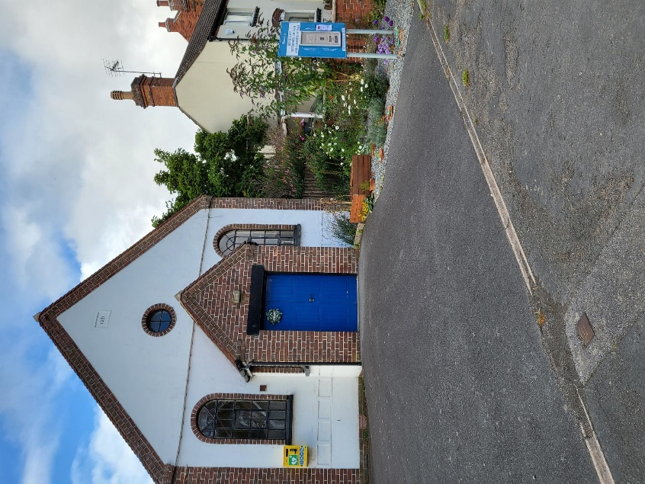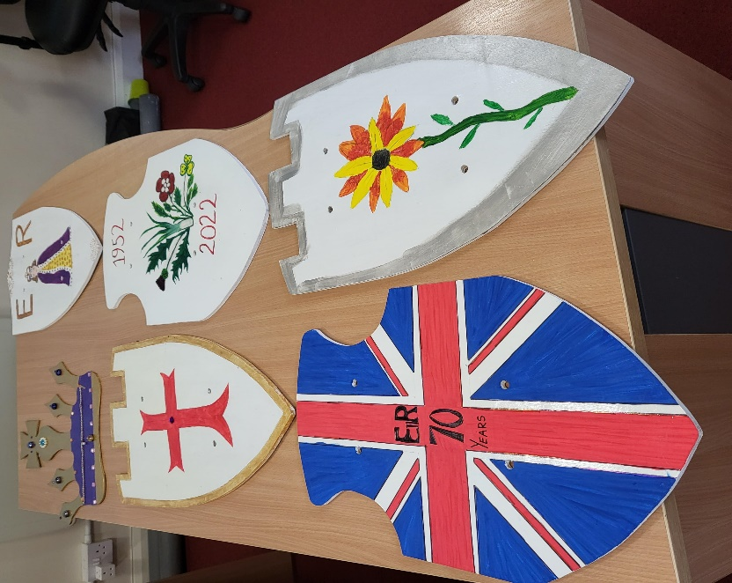REFRESHMENTS WILL BE AVAILABLE. WE HOPE THAT YOU CAN JOIN US TO SHARE IDEAS AND WORK TOGETHER TO BUILD A STRONG COMMUNITY IN MANCETTER AND RIDGE LANE.